DEBUGGING 2
PRESENTED BY: B.HARIHARAN (192511394)

Q1 4. Buggy Code in Stack Push Operation

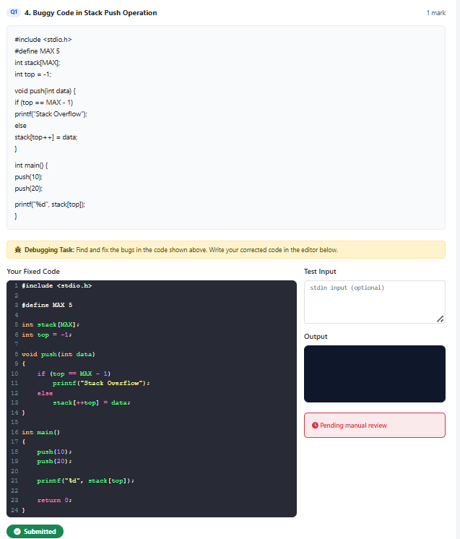
Q2 5. Buggy Code in Stack POP Operation

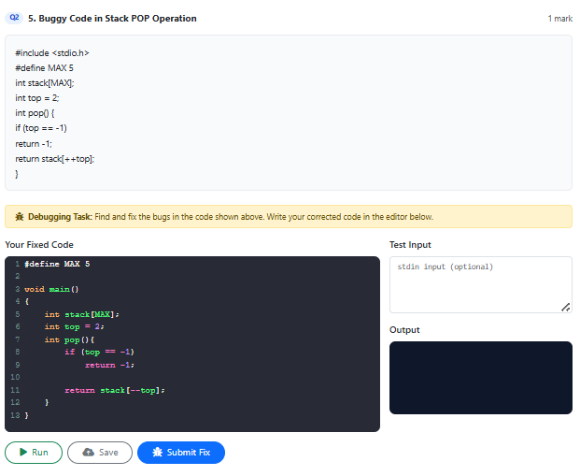
Q3 6. Buggy Code in underflow operation

